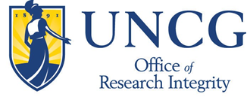

Date: Tuesday, October 25, 2016
Time: 9am-11am
Location: MHRA 2711
Presented by:
Melissa Beck, Assistant Director, Office of Research Integrity
Attendees earn a Human Subjects Research Training certificate to meet FWA assurance and UNCG IRB requirements

To enroll, go to http://workshops.uncg.edu/ - search under “Office of Research Workshops”
For more information, contact: Melissa Beck – mdbeck@uncg.edu or 336-256-0253

